June Newsletter
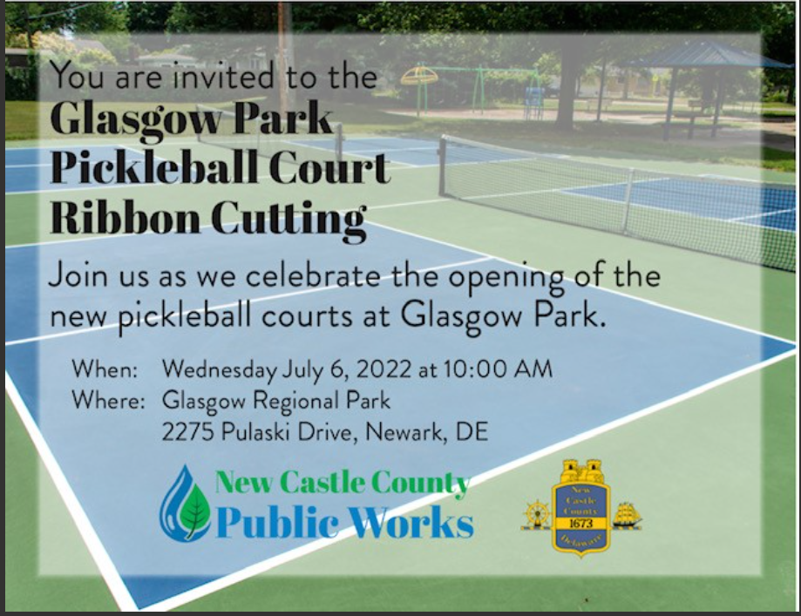

Board of Directors’ Corner:
This Photo by Unknown Author is licensed under CC BY-SA
The DSPC has entered it’s 2022 Fiscal year with the election of the following officers:
President – Gary Conway
Vice President – Julie Besznyak
Secretary – Pat Patnaude
Treasurer – Fran Scholl

Board of Directors:
Ann Cammett
Heather Mergenthaler
John Merritt
Pat Carzo
Linda Walck

Pickleball is growing in DE – Here’s an article on how & where to play in DE:
Pickleball in Delaware, how to play and where to play (delawareonline.com)

Speaking of where to play – did you know that you can find pick-up pickleball games in New Castle County on www.playtimescheduler.com? Playtimescheduler.com allows you to post a game and include time, location, and level of play. If you want to coordinate a private game, you can invite friends… find a pickup game, no problem, or you just may want to watch others who play at a higher level in the hopes that you might learn a few tricks for yourself. It has become a very useful and free tool to find games and I would encourage our members to use it as well. However, it is not a reservation system.

Please use playtime scheduler to signup for play at Deacon’s Walk Park. This information will be presented to New Castle council members in order to potentially add permanent courts at this location.

Tournaments:
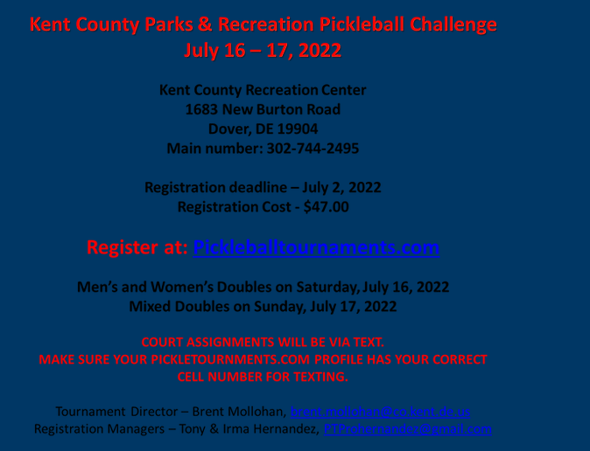

Members Having Fun:
